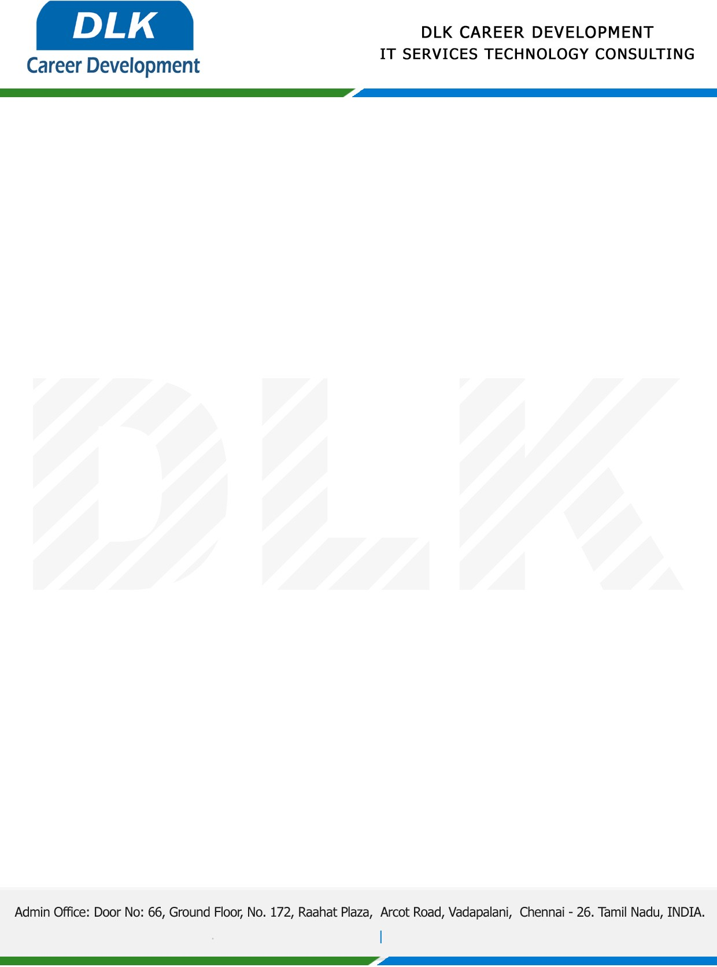

**Date: 31/ January /2023**

**SUB: INTERNSHIP COMPLETION CERTIFICATE**

This is to certify that **MR** **BALAJI M K (REG NO:** **113220071009) B-Tech -** **Information Technology,** third year student **Velammal Engineering College, Chennai** has Successfully Completed the Internship Work under the domain of “**Web Development”** in our organization during the Period **(06th January 2023** to **21st January 2023).**

We appreciate your interest in **DLK CAREER DEVELOPMENT**

**“Best Wishes for Your Future Endeavors “**

